Creating Charts and Tables in R

Pie charts in R

We will begin by making a pie chart. Pie charts are most useful for qualitative data.

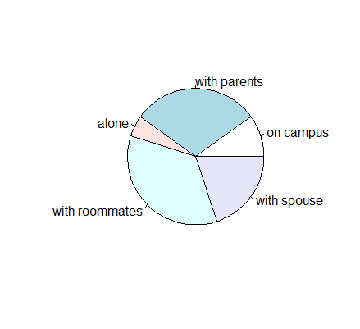
Let’s start with this data: “At a local college, 10% of students live on campus, 30% live with their parents, 5% live alone, 35% live off-campus with roommates, and 20% live with a spouse.” We wish to present it in a pie chart.

Percents = c(10,30,5,35,20)

The second argument, labels, is exactly that. So let’s create that second vector, making sure the labels are in the correct order:

homeType = c("on campus", "with parents", "alone", "with roommates", "with spouse")

Now we can create our pie chart:

pie(percents, homeType)

A pie chart should appear in the Plots tab of the miscellaneous window. You can export it as a bitmap.

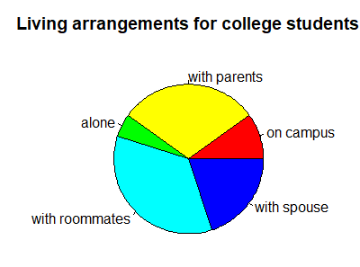
We can use the other arguments to change the colours on the pie chart and the title.

You do: Read over the documentation for the pie command and create the following pie chart. Note that there are colours: red, yellow, green, cyan and blue used in the chart. Copy the pie chart into a Word document and include the command you used to produce it.

We can also create pie charts from built-in datasets. In this example, we are going to use the data from the built-in dataframe survey, which gives data about 237 students. This data is part of the library MASS, so type the command
library(MASS)

to load it.

To view the survey dataset, type:

View(survey)

(Note: R is case-sensitive.)

This will display your data in a tab in the Script window.

This is a useful command. Once we get to the stage of uploading your own data, it is very important to view the data to make sure it uploaded correctly!

You can also see part of your data in the console by typing survey in the console window.

There are many things we can do with this data. First, type

help(survey)

and take a few minutes to read the information about this dataset, which appears in the Help window.

Pie charts are best for qualitative data. Let’s create one for W.Hnd, the student’s writing hand.

As before, we need two pieces of information: the categories, and the number of entries in each category. In this case, the categories are “Left” and “Right”, for the student’s writing hand; and the number of entries are obtained from the W.Hnd column of the data.

We can extract that column with the following command:

hands = survey$W.Hnd

This creates a list called “hands”, which consists of the entries of the W.Hnd column of the survey dataframe. If you type hands into the console, you can see this list.

The table command aggregates this information:

tab = table(hands)
tab
hands
Left Right
18 218

In other words, 18 of the students surveyed are left-handed and 218 are right-handed.

We can then create a simple pie chart:

pie(table(hands))

We can also add the numbers of students of each type by “pasting” those numbers to the labels:

lbls = paste(rownames(tab), sep="\n", tab)
lbls
[1] "Left 18" "Right 218"
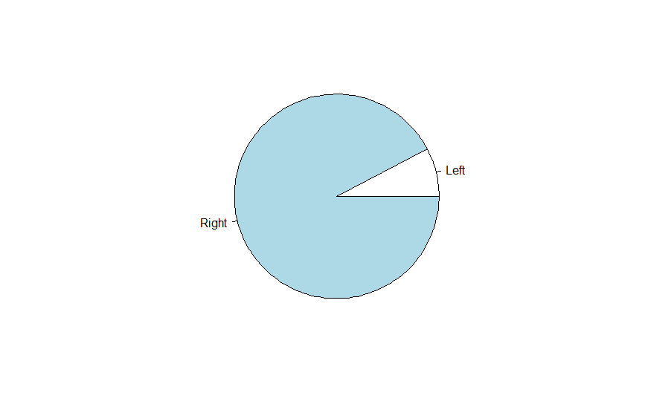
The “\n” tells R to separate the column names and numbers with a new line.

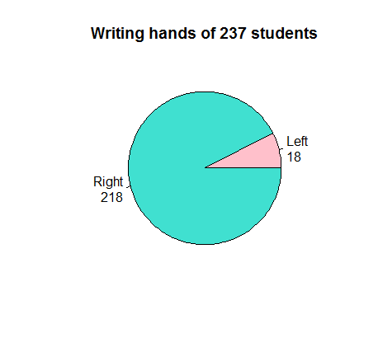
You do: Create the following pie chart. Include the command you used. (Hint: the colours involved are pink and turquoise.) Copy the pie chart into a Word document and include the command you used to produce it.

Bar graphs in R
Alternatively, we can create a bar graph to represent the writing hands of the students.
The command
barplot(tab)

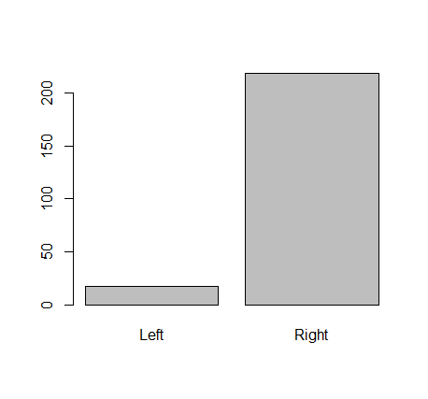
based on the same table you used to create your pie chart, gives the following graph:

You do: Read the documentation for the barplot() command and produce the following barplot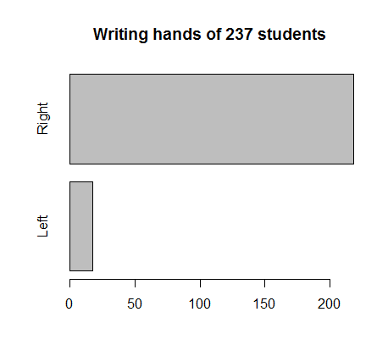

Frequency distributions in R
We will make a frequency table for the survey$Height data.
Let’s say we want to group the data in increments of 5 cm. We will start by getting the range of the data with the command
numHeights = survey$Height[!is.na(survey$Height)]

This gives a list of numerical heights only (ignores the fields with n/a value).
Now we can get the range:
range(numHeights)
[1] 150 200

This tells us that the shortest student is 150 cm tall and the tallest is 200 cm tall. That tells us what our bins should be.
Next we cut the interval [150,200] into sub-ranges of 5cm each.
breaks = seq(150, 205, by=5)
breaks
[1] 150 155 160 165 170 175 180 185 190 195 200 205

We go up to 205 because otherwise our last bin is [195, 200) which excludes any student who is 200 cm tall.
We can now sort the heights into those intervals:
numHeights.cut = cut(numHeights, breaks, right=FALSE)
Finally, we are ready to make a frequency table of the heights:
numHeights.freq = table(numHeights.cut)
cbind(numHeights.freq)
numHeights.freq
[150,155) 6
[155,160) 13
[160,165) 20
[165,170) 45
[170,175) 42
[175,180) 27
[180,185) 28
[185,190) 17
[190,195) 8
[195,200) 2
[200,205] 1

You do: Using the survey data, create two frequency tables for student ages: one for male students, and one for female students. Choose a “reasonable” number of bins and use the same bins for both groups. Include the tables as well as the commands you used to create them. Based on your tables, does it look like the distribution of ages differs significantly between male and female students? Explain.

Histograms in R
We can also display the height data from the last section in histogram form. The command hist(numHeights) gives this histogram:
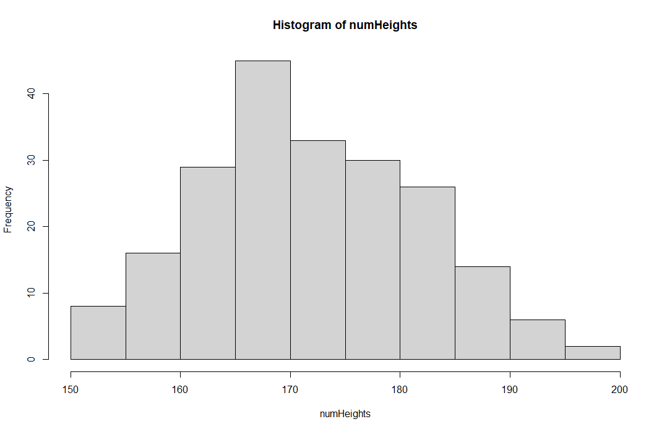
There are a few things to note:
- The bins are each of width 5. This isn’t necessarily bad, but it might not be what we want.
- The label for the x-axis and the title aren’t great.

You do: Go to the Help tab and look up the hist function. Produce the following histogram. Include the histogram as well as the command(s) you used to produce it.
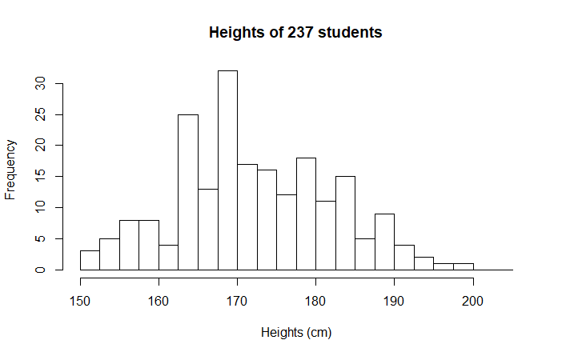

Scatterplots in R
Sometimes we want to know how one variable is related to another. For example, how are height and weight correlated. In general, we expect a tall person to weigh more than a short person – but of course there are exceptions. We say there is a positive correlation between height and weight, but not a perfect correlation.
We will create a few scatterplots based on the survey data. First we will compare the Height variable, which gives student heights in centimeters to the Wr.Hnd variable, which gives the span of the student’s writing hand.
The most basic scatterplot is given by the command
xyplot(survey$Wr.Hnd ~ survey$Height)

(The xyplot() function is found in the lattice library, which should be installed as part of the base installation, but if you are getting and error you may need to install and then load this package now). This produces the following plot
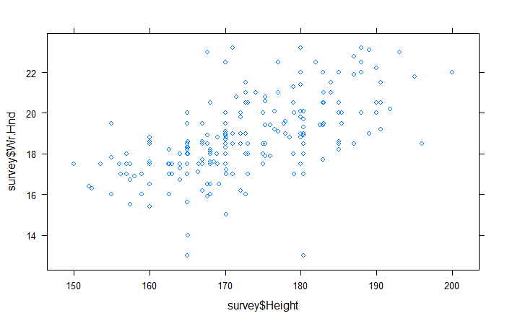
- Use the help function to give descriptive axis labels and a title to the scatterplot above. Include your scatterplot and the command(s) you used to produce it.

- Create two new scatterplots: one that plots Wr.Hnd against NW.Hnd, and one that plots Height against Pulse. Both plots should have descriptive titles and axis labels. Include your plots along with the command(s) used to produce them, and answer the following questions: How do the graphs compare to one another, and to the Wr.Hnd vs Height graphs? What does this tell you about the correlation between each of the three variable pairs?

